 | Diyala Journal of Engineering Sciences |  | 
Journal homepage: https://djes.info/index.php/djes

ISSN: 1999-8716 (Print); 2616-6909 (Online)
A Title Should be the Fewest Possible Words that Accurately Describe the Content of the Paper (Left-Aligned, Bold, 16pt)
First Author¹*, Second Author² , Third Author¹ (12 pt)
¹ Department of Computer Engineering, University of Diyala, 32001 Diyala, Iraq (8 pt)
² Department of Electrical Engineering, University of Baghdad, Baghdad, Iraq (8 pt)
ARTICLE INFO |  | ABSTRACT
Article history:  Received xxxx  Revised xxxx,  Accepted xxxx,  Available online xxxx |  | A well-prepared abstract enables the reader to identify the basic content of a document quickly and accurately, to determine its relevance to their interests, and thus to decide whether to read the document in its entirety. The Abstract should be informative and completely self-explanatory, provide a clear statement of the problem, the proposed approach or solution, and point out major findings and conclusions. The Abstract should be 200 to 250 words in length. The abstract should be written in the past tense. Standard nomenclature should be used and abbreviations should be avoided. No literature should be cited. The keyword list provides the opportunity to add keywords, used by the indexing and abstracting services, in addition to those already present in the title. Judicious use of keywords may increase the ease with which interested parties can locate our article (10 pt, Italic).
Keywords:
First keyword
Second keyword
Third keyword
Fourth keyword
Fifth keyword

- INTRODUCTION (BOLD, 11 PT)
The main text format consists of a two column on A4 paper, single space, Time New Roman 11pt.
The Introduction should provide:
- Background of the study
- Clear problem statement
- Research gap
- Objective and contribution
- Structure of the paper (optional)
- Citations must follow IEEE style [1], [2–4].

- LITERATURE REVIEW
Literature review that has been done author used in this section to explain the difference of the manuscript with other papers, that it is:
- Critically analyze prior work
- Identify limitations in previous studies
- Clearly demonstrate novelty
- Avoid listing papers without analysis.

- METHODOLOGY
Explaining research chronological, including:.
- Research design
- System architecture
- Mathematical modeling (if applicable)
- Algorithms (formatted pseudocode)
- Experimental setup
- Dataset description
- Evaluation metrics

3.1 Sub section 1(11pt, Italic)
The most widely used and well discussed in the scientific papers is the class of genetic algorithms. The genetic algorithm is the first presented among the class of evolutionary algorithms.

3.2 Figures and tables
Tables and figures should be placed either centered on the page (when necessary) or positioned within the column layout, as illustrated in Table 1 (centered) and Figure 1 (within the column).

Figures:
- Minimum resolution: 300 dpi
- Format: TIFF, PNG, or high-quality JPEG
- Caption below figure
- Number sequentially (Figure 1, Figure 2…)
- Refer to figure before appearance
Tables:
- Caption above table
- Use editable table format (not image)
- Number sequentially (Table 1, Table 2…)

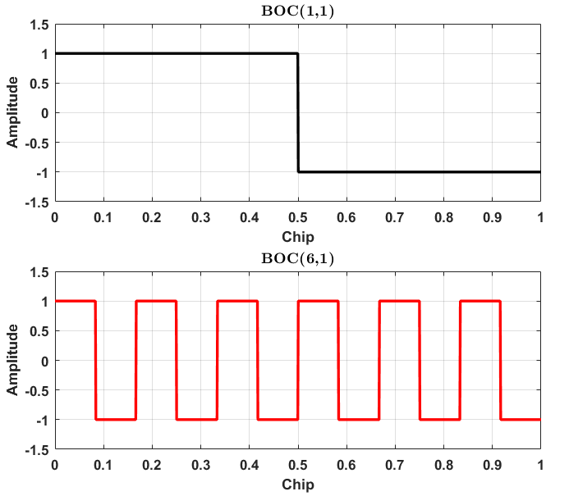
Figure 1. BOC (1,1) and BOC (6,1) Modulation (10pt, left-aligned)

- RESULTS AND DISCUSSION
In this section, it is explained the results of research and at the same time is given the comprehensive discussion. Results must be presented clearly using:
- Tables
- Graphs
- Statistical analysis
- Comparative evaluation
- Performance comparison
- Error analysis
- Interpretation of findings
- Practical implications
- Limitations
- Subsections allowed (4.1, 4.2, etc.)

4.2 Mathematical Formulation
All equations must be:
- Cantered.
- Numbered consecutively.
- Referred to in the text as (1), (2), etc.
Example:
$E= {mc}^{2}$ (1)

Variables must be defined immediately after the equation. Use italic font for variables (e.g., x, y, n). Do not insert equations as images.

4.3 Algorithms
Algorithms should be formatted clearly:

Algorithm 1: Proposed Method
Step 1: Initialize parameters
Step 2: Compute objective function
Step 3: Update weights
Step 4: Return results

Table 1. Chemical composition of 7075-T6 Al alloy in wt% (10pt, center-aligned)
Al | other | Ti | Zn | Cr | Mn | Mg | Cu | Fe | Si | AA7075-T6
Balance | 0.09 | 0.032 | 5.61 | 0.19 | 0.12 | 2.2 | 1.87 | 0.3 | 0.28 | EXPERMENTIAL
Balance | ≤  0.15 | ≤  0.2 | 5.1  6.1 | 0.18  0.28 | ≤  0.3 | 2.1  2.9 | 1.2  2.0 | ≤  0.5 | ≤  0.4 | STANDARD
Balance | 0.09 | 0.032 | 5.61 | 0.19 | 0.12 | 2.2 | 1.87 | 0.3 | 0.28 | EXPERMENTIAL

- CONCLUSIONS
Provide a statement that what is expected, as stated in the "Introduction" chapter can ultimately result in "Results and Discussion" chapter, so there is compatibility. Moreover, it can also be added the prospect of the development of research results and application prospects of further studies into the next (based on result and discussion).
REFERENCES
The main references are international journals and proceedings. All references should be to the most pertinent and up-to-date sources. References are written in IEEE style, at least 12 References of current related published research. Please use a consistent format for references – see examples below (9 pt):
- F. Yan, Y. Gu, Y. Wang, C. M. Wang, X. Y. Hu, H. X. Peng, et al., "Study on the interaction mechanism between laser and rock during perforation," Optics and Laser Technology, vol. 54, pp. 303-308, Dec 2013.
- L. Liu and H. Miao, "A specification-based approach to testing polymorphic attributes," in Formal Methods and Software Engineering: Proceedings of the 6th International Conference on Formal Engineering Methods, ICFEM 2004, Seattle, WA, USA, November 8-12, 2004, J. Davies, W. Schulte, M. Barnett, Eds. Berlin: Springer, 2004. pp. 306-19.
- M.R. Brooks, “Musical toothbrush with adjustable neck and mirror,” U.S Patent 326189 [Online], May 19 1992. Available: http://goo.gl/VU1WEk
- J. O. Williams, “Narrow-band analyzer,” Ph.D. dissertation, Dept. Elect. Eng., Harvard Univ., Cambridge, MA, 1993.
- B. Klaus and P. Horn, Robot Vision. Cambridge, MA: MIT Press, 1986

* Corresponding author’s E-mail: diyalamag@gmail.com | ORCID: 0000-0000-0000-0000 DOI: 10.24237/djes.xxxx.13301 This work is licensed under a Creative Commons Attribution 4.0 International License.

